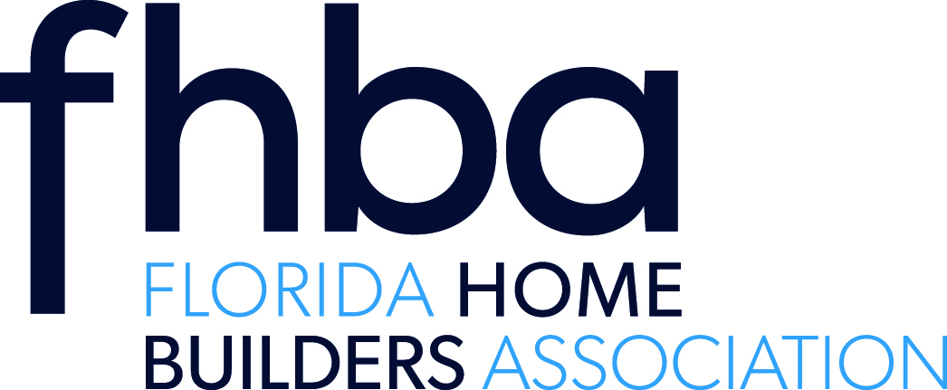
BOAF – FHBA Joint Training- Building Code Seminar
April 28, 2016
Advanced Technology College (ATC)
1770 Technology Blvd.
Room 109
Daytona Beach, FL 32117
Presenter: John Farinelli
Times | Class Schedule
8:00 – 8:30 | Registration
8:30 – 9:30 | FBC – Building Chapters 7, 8 & 9, Update 5th Edition  Provider # 0001001 - CILB # 0611028 - AIA # RS201601 – Preferred Provider # 6577  This course will familiarize participants with the FBC requirements for fire rated construction, importance of flame spread and smoke development characteristics of interior finishes, and the application of fire protection systems.
9:30 – 10:30
10:30 – 11:30 | FBC – Building Chapter 10 Egress  Provider # 0001001 - CILB # 0611131 - AIA # RS201602 – Preferred Provider # 6576  Participants in this class will learn the essential principles for designing, constructing, and inspecting egress systems per FBC- Building Chapter 10.
11:30 – 12:30

12:30 – 1:30 | Lunch
1:30 – 2:30 | 2014 Advanced Significant Code Changes Florida Building Code, Building 5th Edition, Module I  Provider # 0004764 - CILB # 0610634 - AIA # RS201607 – Preferred Provider # Pending  It is the intent to familiarize the participants with the current edition of the Florida Building Code, Building Volume and the changes made during the current cycle. New sections and important revisions will be presented to provide the attendees with information related to the current edition of the Florida Building Code.
2:30 – 3:30
3:30 – 4:30 | The Role of the Building Official in Enforcing the Florida Lien Law  Provider # 0001001 - CILB # 0009630 - AIA # RS201604 – Preferred Provider # 6574  This course will familiarize the participant with the statutory requirements of the Florida ... Lien Law during the building permit process.

